Lecture 17

**FSCK-Repairing the HDD**

* When computer starts, the OS is loaded in the RAM.
* And every process is processed in RAM.
* Data is loaded in the RAM from storage (HDD) according to instructions.
* **$ touch xyz** 🡪 this file is created in HDD as a result of instruction by RAM
* **$ rm -rf /\*** 🡪 this command erases whole OS from HDD but it is initiated from RAM
* “mount” command loads “file system” in RAM
* Filesystem has collection of metadata, inodes, Inode tables, super blocks, mount information.
* FAT32 = ext2
* NTFS = ext2 🡪 this is for the sake of comparison only to give an over view.
* Updated file systems give the facility to recover the data as compared to an old file system
* Ext3 = 320000 directories can be made
* 4xt4 = 64000 directories can be made
* “File system” is “father” of all the directories/folders and files inside a partition. “file system” controls all the directories and files in a “partition”.
* **$ df -Th** 🡪To check the file system.
* 
* **Differences b/w FSs**
* FS organizes/controls/ manages data in a partition.
* Ext2 🡪 non journaling file system, if power is off chances of corruption of data are high
* Ext3 🡪 it has journaling, if power is off it maintain additional metadata which helps to recover the data due to journaling, it has fast. crash recovery. Journaling is not off, 32000 directories can be created,
* Ext4 -🡪 journaling can be off, 64 000 directories,
* **Journaling 🡪 to maintain additional metadata records.**

|  |  |  |  |
| --- | --- | --- | --- |
| **Ext2** | **Ext3** | **Ext4** | **Xfs** |
| **-non journaling FS**  **-chances of corrupt data are high if power is off** | **-journaling FS**  **-Journaling FS can’t be turned off**  **-32k directories can be created**  **-single file size can be upto 2Tb** | **-journaling can be turned off**  **64k directories.**  **-single file size upto 16Tb**  **-data performance average**  **-can’t take snapshot**  **-file system reduce with LVM** | **-journaling on/off**  **-data performance is excellent**  **-snapshot enabled**  **-can’t reduce FS** |

* **“mount” command loads File System into RAM**

To persistent we need to add these newly created partition in”fstab” 🡪 /etc/fstab/

* Within “fstab”
* 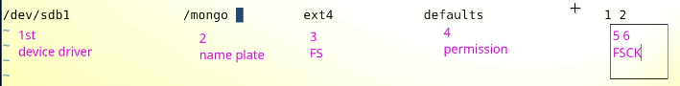
* “fstab” must be tested before rebooting or the OS will crash and do not boot
* The command is
* $ mount -a 🡪 it refers the fstab and mounts the unmounted partitions.
* After restart system reads **“fstab”** for **“auto mounting”** the partitions.

**Today’s topic is “FSCK”**

* **FSCK** 🡪 File System Check & Repair
* To check “bad blocks”
* **& badblocks -v /dev/sdb1**
* If “badblocks” found 🡪 cleaning (fsck)
* How to repair file system
* With fsck command
* 2nd command “e2fsck2”
* $ e2fsck /dev/sdb1
* 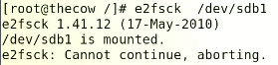
* Because the selected partition “/dev/sdb1” is in use or mounted, the error appeared
* So to check it we need to **“unmount”** it first
* **$ e2fsck -yc /dev/sdb1**